

Flux OF souls

Game Manual



December 5, 2013

cALIPH ET AL.

Centennial College

Contents

Getting Set Up 2

Main Menu 3

In-Game 4

Next turn 5

End Game Screen 6

Leaderboard 7

Gameplay 8

Caliph et al. 9

# Getting Set Up

* After executing and run the provided set up file you will be greeted with the below screen.



* Press the space bar to continue.

# Main Menu

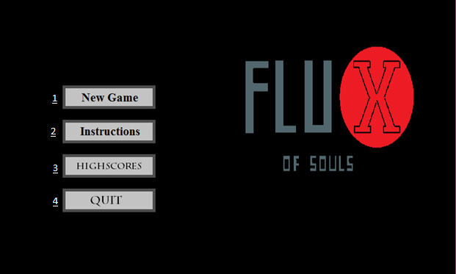

1. New Game – This Option will guide you to the difficulty screen where you can choose from three Easy, Normal and Expert,
2. Instructions – This option will be up a screen with a text based explanation of the game and the mechanics.
3. HighScores - This will show all the current scores and names from highest to lowest.
4. Quit – This will close the application.

# In-Game

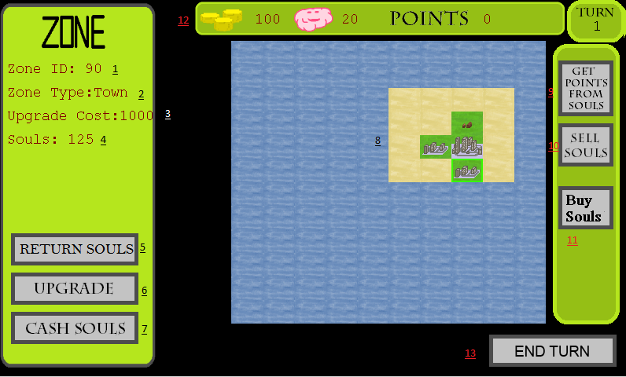

1. Zone ID – This indicates the zone id of the one that is currently selected.
2. Zone Type – This will indicate the current level of the zone.
3. Upgrade Cost – This will show the amount of gold need the upgrade the selected zone.
4. Souls – The Current amount of souls in the zone.
5. Return souls – This option will put souls from your pool back into the selected zone.
6. Upgrade – This option will upgrade the selected zone.
7. Cash souls – This option will sell all souls on the selected zone.
8. Map – This is the game world where you can select a zone and view its info on the left side menu.
9. Get Points from Souls – This is the conversion button that will converter souls from your pool to points.
10. Sell Souls – This Button will sell souls from your pool for currency.
11. Buy Souls – This Button will buy souls in exchange for some currency.
12. Top Bar – The top bar give you the status of from left to right your current gold amount, Number of souls in your pool, current point score and current turn.
13. End Turn – this will end the turn and move to the next

# Next turn

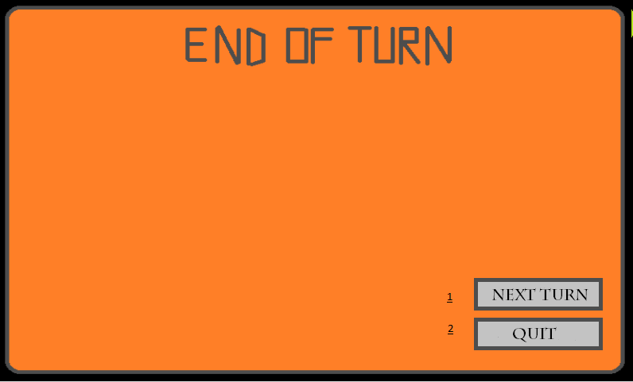

1. Next turn – This button will progress you back to the game screen and advance to turn.
2. Quit – This Button will send you back to the Main Menu.

# End Game Screen

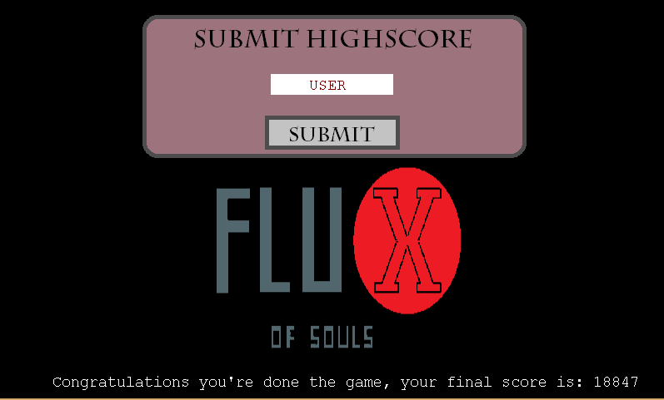

* This is the end game screen where you are able to type in a name and click submit to post your score to the leaderboard.

# Leaderboard

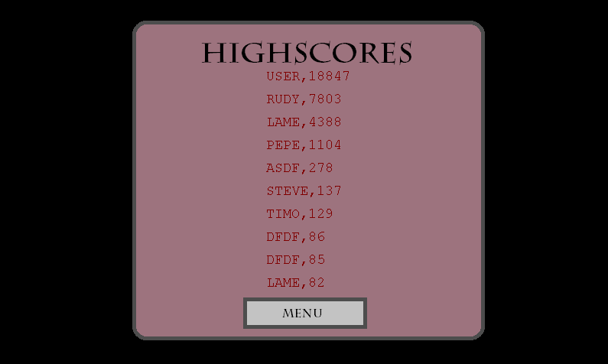

* This screen will contain the scores of the top past players.

# Gameplay

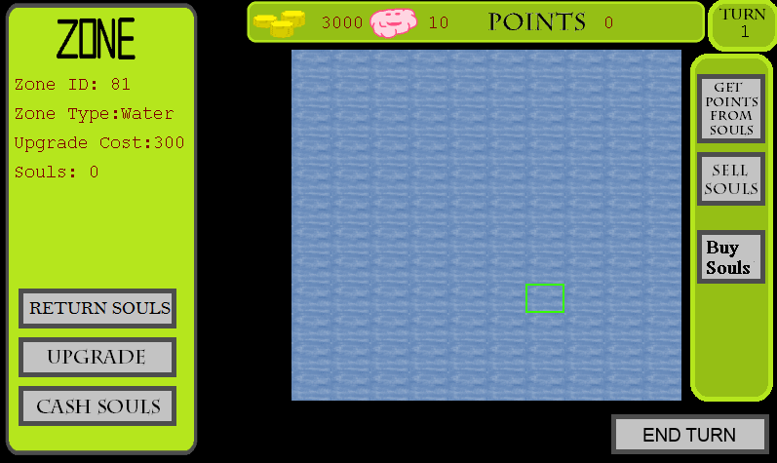

* Create your world, by balancing money, upgrading of zones and managing souls try to get the highest score and get that top spot on the leaderboard. Good Luck!

# Caliph et al.

|  |  |
| --- | --- |
| Role | Name |
| Scrum Master and Project Owner | Rudy Caliph |
| Developer | Stephen Dos Santos |
| Developer | Craig Rose |
| Developer | Randy Peacock |
| Developer | Richard Andrews |
| Developer | Tobias Perez |

* Above are the names of the members of the team that worked on this project